**Dynamism’s western redoubt: xyz**

**Key findings:**

* Eight out of 10 of the country’s most dynamic states are in the West, led by Utah, Idaho, and Colorado. Delaware topped the index overall.
* The country’s least dynamic states can be found in the Eastern Heartland, with West Virginia scoring lowest on the index.
* Dynamism declined in the average state from 2019 to 2020, hitting an all-time low in 12 states.
* Seven of eight individual measures of dynamism have declined over the past three decades in the average state, with patenting rates the lone bright spot. There are individual states that buck the downward trend on every measure, however.

**Western states lead the rankings on EIG’s latest Index of State Dynamism**

Western states tend to have much more dynamic economies than their eastern or heartland counterparts. Eight of the nation’s 10 most dynamic state economies are in the western half of the country, according to the latest results from EIG’s Index of State Dynamism (ISD). Utah is the top-scoring state in the region and second overall, followed closely by Colorado and Idaho in third and forth, respectively. Delaware tops the index, shooting up 12 places into the #1 spot on the back of exceptionally high startup activity in 2020. Washington, DC, is the only other non-western jurisdiction to break into the top 10, fueled by high labor force participation and the abundant issuance of new housing permits.

The Index of State Dynamism (ISD) evaluates states on [eight different aspects of economic dynamism](https://docs.google.com/document/d/1wD3RPDoxHxjxS7aFwD7yTuosCRMiDAuOdGaTuw7QsHk/edit) to provide a single summary score that enables comparisons both across states and over time. The index is calculated from 1992 through 2020, the latest year for which data are available.

Visit ISD’s immersive interactive home for a full exploration of the components and trends.

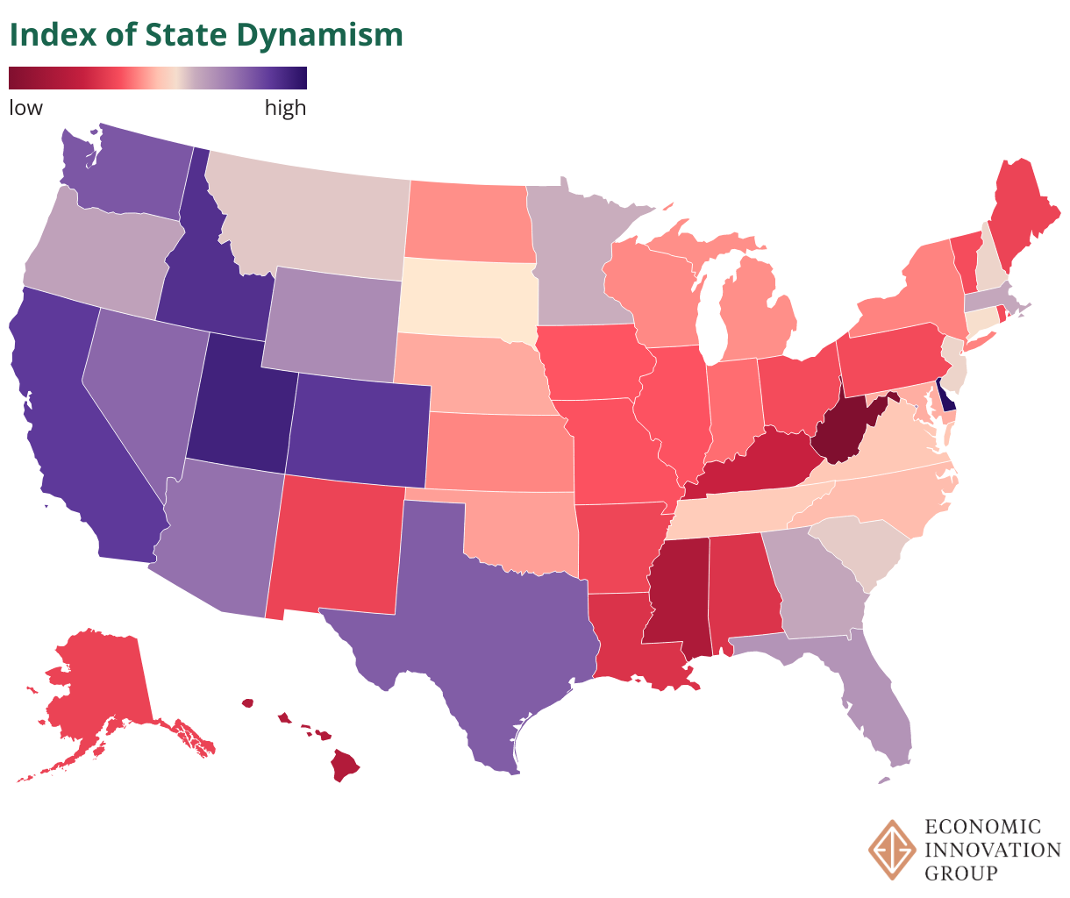

[https://datawrapper.dwcdn.net/lLcrs](https://datawrapper.dwcdn.net/lLcrs/9/)

Outside the West, pockets of dynamism can be found in the Southeast, with Georgia, Florida, and South Carolina standing apart from their peers. These states tend to benefit from high startup rates and positive in-migration. Led by Massachusetts, a handful of northeastern states also demonstrate above-average levels of dynamism, though to a lesser extent than their Western counterparts. Several of these northeastern states perform close to the average on most metrics but are buoyed by high patenting rates, attesting to their strength in innovation.

***What is dynamism?***

*The concept of dynamism captures the intrinsic vitality of an economy: how quickly it changes, how efficiently it redeploys its resources to the most productive use, and how successfully it translates experimentation into opportunity. Dynamism has been in retreat across the U.S. economy for decades, however. While the downsides of declining dynamism may not always be immediate or obvious, a less dynamic economy tends to be less resilient to shocks, less innovative, less productive, and poorer in opportunity over the long-term. A more dynamic economy, in contrast, is more likely to be able to successfully navigate future change and secure economic well-being for its citizens in the process.*

Among the most populous states, California maintained its edge on Texas, ranking 5th nationwide compared to Texas’ 7th. Both states have high startup rates and relatively large shares of their workforces in young firms, but California’s advantage in patenting made up for its below-average performance on migration and housing permits. Florida followed at 12th, lagging behind on measures of innovation (patenting) and labor force participation, reflecting the dominance of retirees in its economy. New York’s dynamism score reached an all-time low, and at 33rd, the state registered its worst ranking since 2007. Nevertheless, New York’s relative performance remains much stronger than it was in the 1990s or early 2000s.

< could include extract and cross-post to the interactive here >

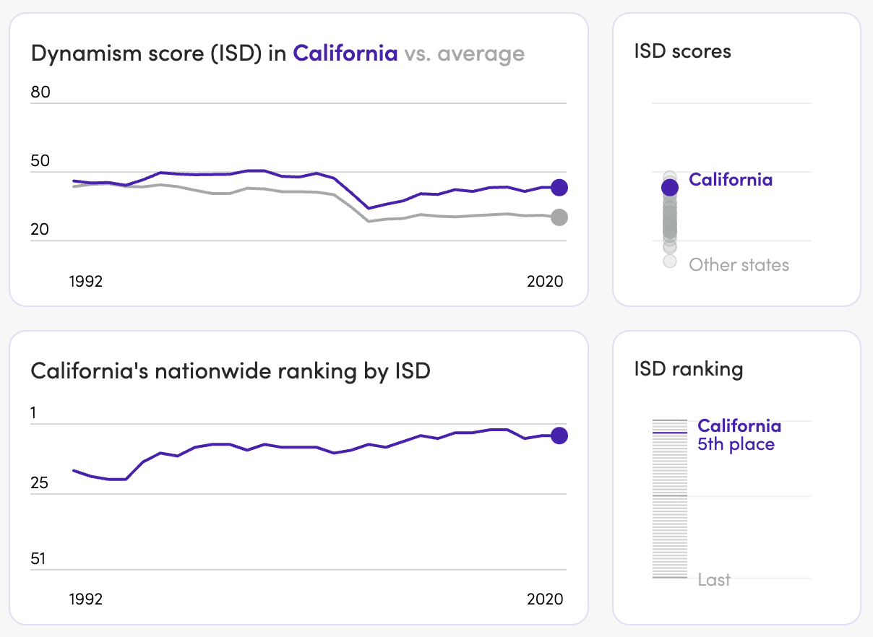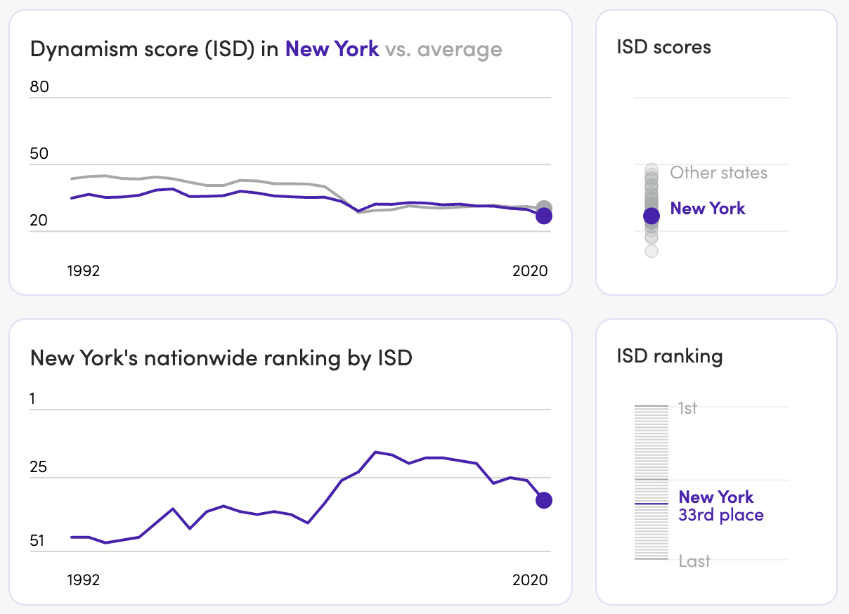

**Dynamism is strongly correlated with population growth.**

Many factors contribute to the underlying dynamism of an economy, from laws and institutions to capital ecosystems and the risk tolerance or entrepreneurial energies of its people. Another factor is population growth. Many of the country’s most dynamic states are also adding residents at a rapid clip. The direction of causality is difficult to tease out, however, because the two phenomena reinforce each other. Population growth encourages dynamism by ensuring a steady supply of new workers, consumers, and entrepreneurs fuel the local economy. In turn, dynamic economies encourage population growth by creating new jobs, industries, and opportunities. The inverse, population loss, exhibits a similar relationship in the opposite direction, with low or negative growth contributing to and reinforced by low levels of dynamism.

Population growth over the past decade exhibits a 0.57 correlation with 2020 dynamism scores. That relationship is tighter than those between dynamism scores and educational attainment, incomes, or poverty rates. Population growth alone is not what fosters dynamism, of course—California, DC, and Delaware are all states whose dynamism scores are much higher than their population growth rates would predict—but it is an important contributor, and healthy population growth makes maintaining a dynamic economy easier. As the nation’s population growth slows, more states may begin to feel the drag. Population loss, for its part, saps economies of their dynamism by removing human capital and shrinking the local marketplace; low dynamism economies struggle to generate the opportunities to retain, let alone attract,

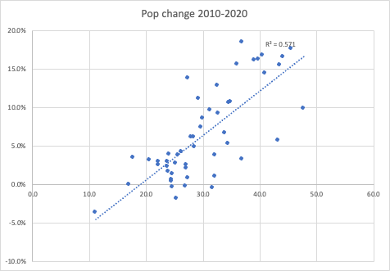

**Dynamism lags in the center of the country**

Lagging dynamism also exhibits a starkly regional pattern, with the lowest-performing states clustered in the center of the country. The pattern aligns closely with the geography of the [so-called Eastern Heartland](https://www.brookings.edu/bpea-articles/saving-the-heartland-place-based-policies-in-21st-century-america/), which generally follows the Ohio and Mississippi River basins where numerous social and economic indicators tend to lag behind. West Virginia is the country’s lowest-performing state, a position it has occupied for all but two years since 1992. Mississippi and Hawaii follow. Within the West, New Mexico stands out as a low-dynamism outlier, consistent with its chronic underperformance relative to regional peers across economic indicators.

Low-scoring states tend to be more rural or reliant on a limited set of industries—often natural resource-based—to power their economies. From Alaska to West Virginia, these industries tend to offer poor foundations for economic diversification, and remoteness combined with rurality make sustaining dynamism difficult. Just as positive economic outcomes can be reinforced in more dynamic economies, dynamism laggards often trail on other measures linked to economic performance, such as educational attainment and poverty rates. The pace of economic churn and change are lower in these states, and residents are worse-off for it.

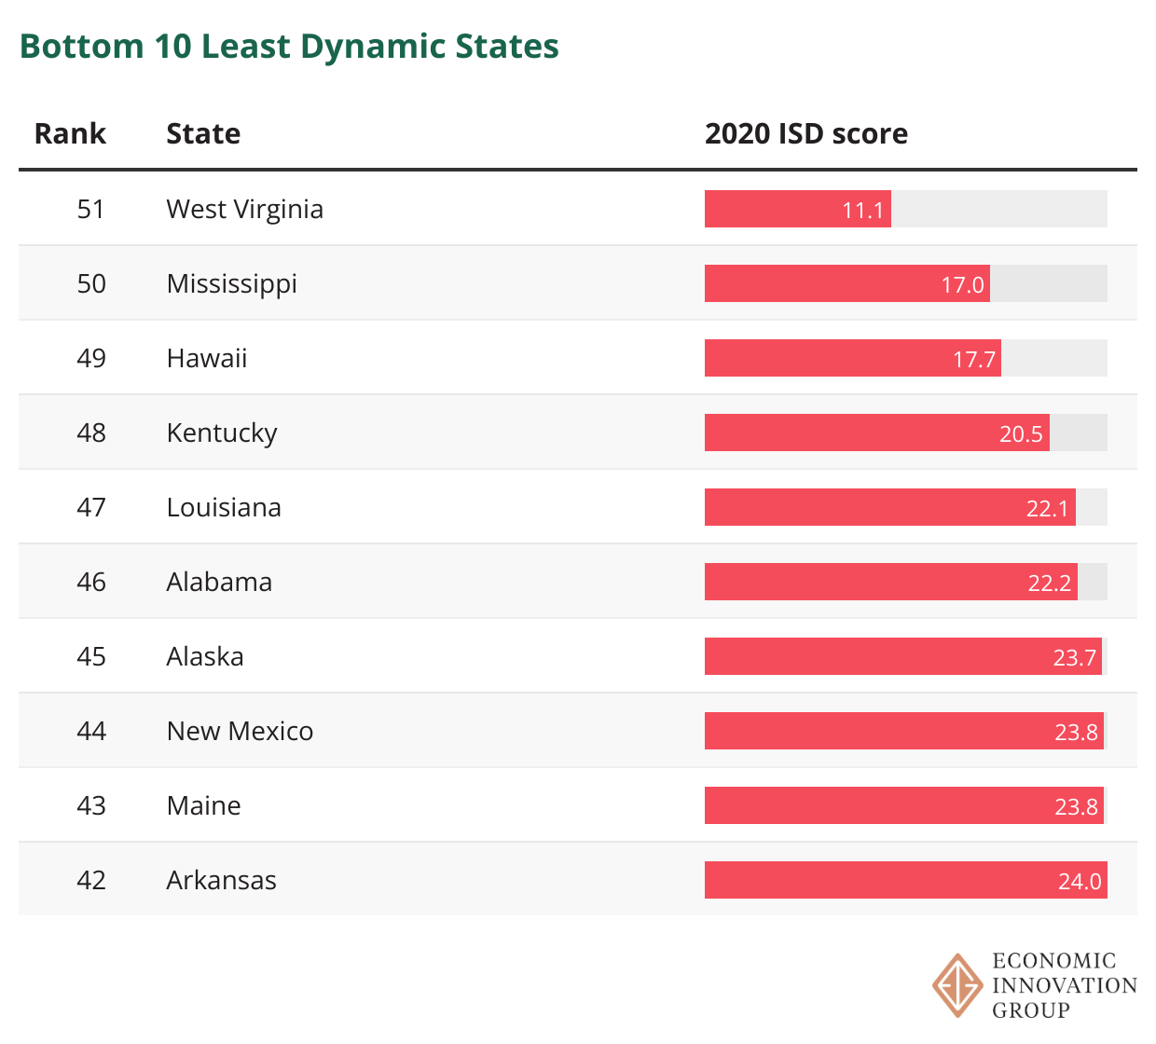

**States entered the pandemic with dynamism at or near record lows**

The United States entered the pandemic with dynamism at a low ebb. The average state dynamism score has fallen by more than 30 percent since the early 1990s. The bulk of that decline occurred with the Great Recession, during which most related indicators fell precipitously and after which they failed to recover. The average state’s dynamism score declined again from 2019 to 2020, though, and hit an all-time low in 12 states. Annual scores were pushed lower that year by a decline in labor force participation and a contraction in the total number of firms in the economy.

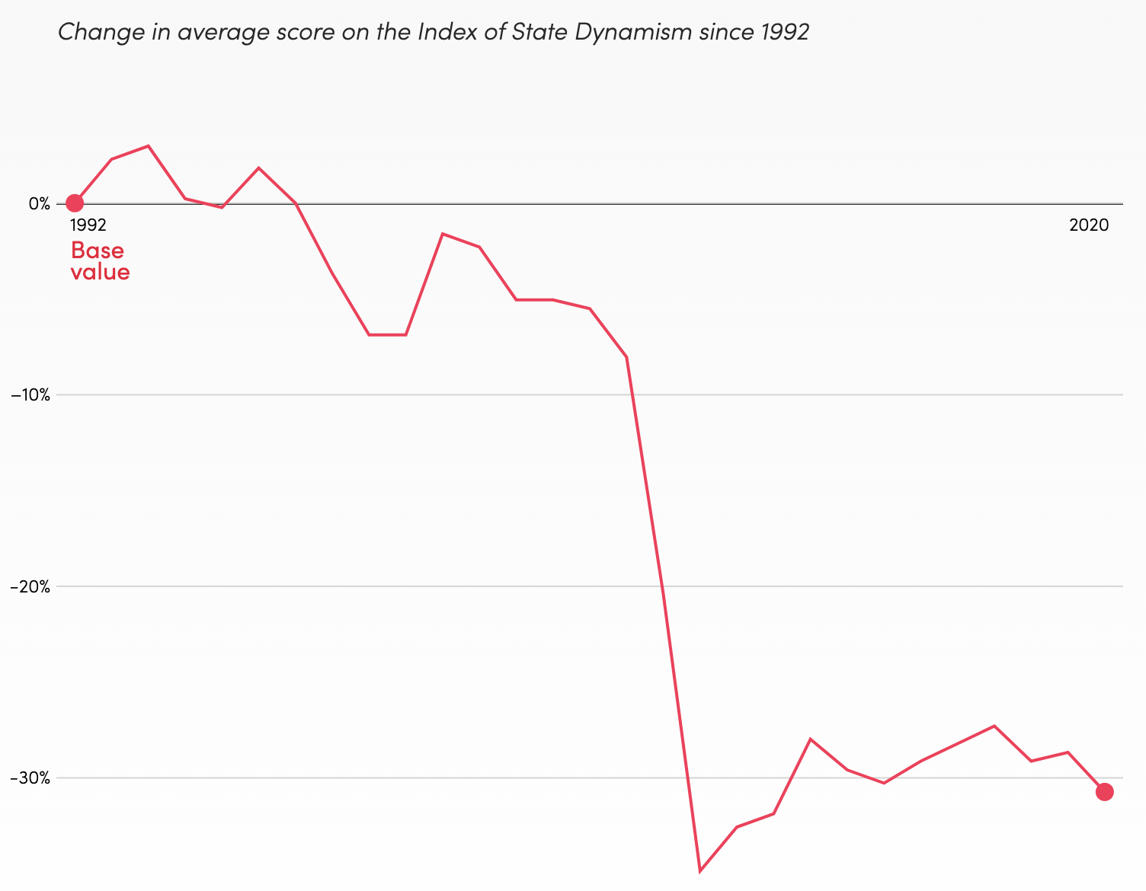

A handful of states have broken out of stagnation to register partial dynamism recoveries in the past few years, however. Ten states were within 80 percent of their 2006 dynamism scores in 2020, including California and Texas. Two states—Delaware and DC—already register scores above their mid-2000s peaks. Connecticut and Massachusetts were relatively low dynamism states before the Great Recession but suffered less from that event’s fallout and have proven resilient since, placing them closer to a dynamism recovery than many peers. The three worst-scoring states in 2020—West Virginia, Mississippi, and Hawaii—were also the furthest from their pre-Great Recession levels of dynamism, hinting at the relationship between dynamism and resilience.

**Declining startup rates have led dynamism’s downard charge**

A majority of the underlying component metrics that make up a state’s ISD score have weakened over time, but few have fallen as dramatically and pervasively as the startup rate. The breakdown of new business formation is clearly evident across all states following the Great Recession, with core startup rates consistently lower than they were prior to the financial crisis. The average share of jobs in young companies has also declined since 1992. States that manage to perform well both overall and relative to their peers on startup-related metrics tend to have strong population growth and relatively high net migration rates—two contributing factors for new business formation. For its part, California still reaches the top ranks of startup states on the sheer strength of its ecosystem.

Migration also slowed dramatically with the Great Recession, sapping the ability of local labor markets to adjust and pushing dynamism rates lower across the board. The financial crisis that sparked the Great Recession originated in the housing market, and one of its legacies was a decline in housing permits per capita. Only Washington, DC, Delaware, Montana, South Dakota, and Nebraska permitted more housing units per capita in 2020 than in 2006. Even though 2020 saw a 15-year high for the average state on the measure, the number of housing permits across the country remained roughly 500,000 units per year below pre-Great Recession highs. The slow rate of building contributed to rapidly rising housing costs that made it harder again for places to adjust economically and for productive new economic activity to take root. Labor force participation and labor market churn also fell across the board over the study period.

The only component metric to buck the general trend of decline is the number of patents issued per 1,000 people, which has risen in all but three states since 1992. The group of patenting leaders has been relatively stable over time as well, led by states such as California, Connecticut, and Massachusetts.

**Clear regional strengths emerge from the index**

Each component metric has its own distinct pattern of geographic variation that becomes evident when looking at a map of each state’s best performing metric. These strengths tend to cluster regionally, too. Patenting lifts dynamism scores most on the Pacific Coast and in New England, as well as Minnesota (led by medical devices, among other industries) and Michigan (automotive). Labor force participation contributes disproportionately to dynamism scores in the high-employment regions of the Great Plains and Mid-Atlantic. Elastic housing supplies push dynamism higher in the Mountain West and Southern growth hubs like Texas and Tennessee. Strong core startup rates fill in the map of the Southeast. The only anomalies are the states whose best performance is on migration: most of these states lag on every indicator, but lag least on this one.

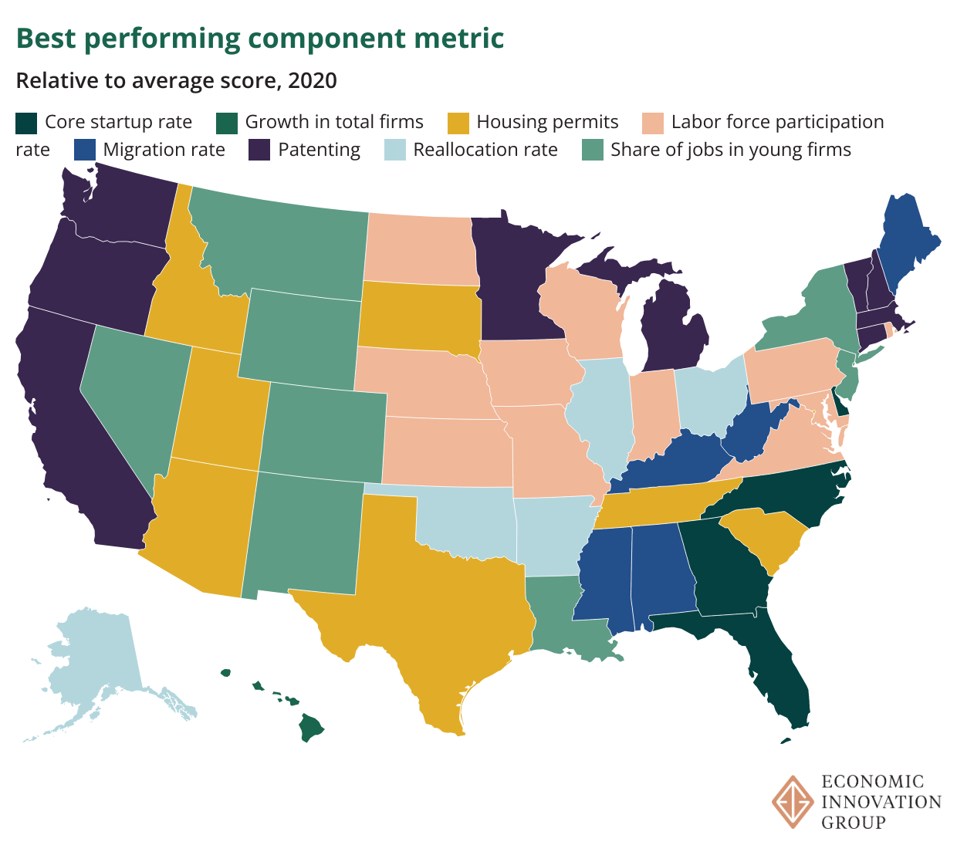

[**https://datawrapper.dwcdn.net/reZdH/2/**](https://datawrapper.dwcdn.net/reZdH/2/)

**Conclusion**

Where will dynamism head from here? Even as long term trends remain decidedly downbeat, dynamism likely ticked higher in 2021 and 2022 in most states as labor markets tightened and applications to start new business [remained near record highs](https://eig.org/2022-business-formation/). Shifting migration patterns and record quits all point to rekindling churn under the surface of the American economy, but the magnitude of these developments and their geography is still uncertain—not to mention their longevity or durability. The ISD will be updated annually to follow the evolution of American dynamism, with the next annual update (with data for 2021) expected in fall 2023.

**Explore each state’s performance across the eight component metrics of the ISD below and here.**

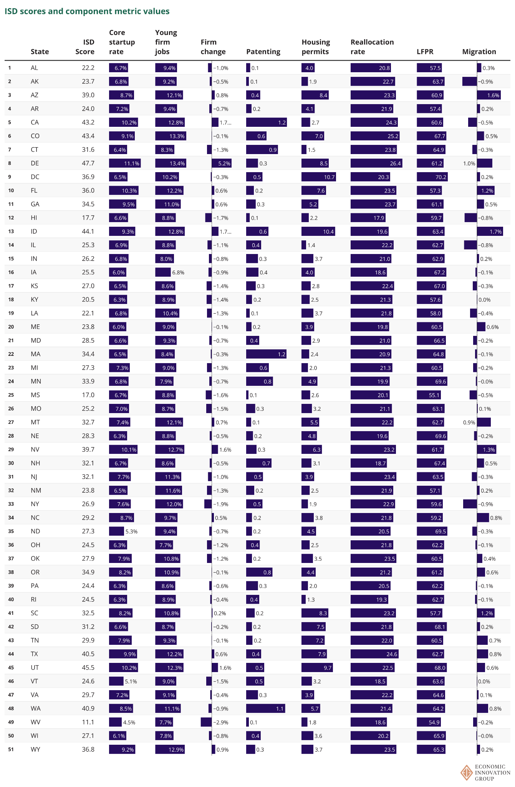

[https://datawrapper.dwcdn.net/qJSND](https://datawrapper.dwcdn.net/qJSND/7/)